**A-5.**

**Circuit Analysis Methods**

**OBJECTIVES:**

After performing this experiment, you will be able to:

1. Write loop and node equations for a resistive circuit.

2. Prove, through measurement, that the equations written in objective 1 are valid.

**READING:**

Nilsson, Electric Circuits, Sections 4.1 through 4.8 and Application Activity

**MATERIALS NEEDED:**

One 1.0 kΩ, one 2.0 kΩ, one 3.6 kΩ, one 4.7 kΩ, one 10 kΩ

**SUMMARY OF THEORY:**

Reducing a circuit by substituting equivalent parallel or series elements is a technique that works in most but all circuits. Sometimes a circuit can have a complex group of elements which are not in either a series or parallel combination such as the bridged-t circuit shown in figure 15-1. For such a circuit, the method of loop equations or the method of node voltages is applicable.

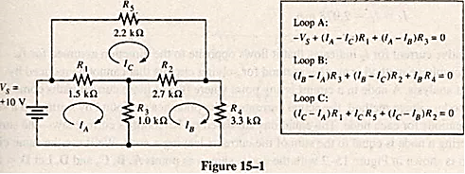

The loop equation method of analysis leads to a set of simultaneous equations which can be solved by algebraic methods. The equations are written by assigning “fictitious” currents around any closed path (called loops) in a circuit. There must be at least one loop current in every branch, and a particular loop current cannot be the only loop current in two or more branches. The loop currents are indicated by an arrow that closes on itself and defines the current that flows around the perimeter of a loop.

Although the direction of loop currents is arbitrary, to minimize errors it is a good idea to choose the same direction when writing loop currents (we will use the clockwise direction). Kirchhoff’s voltage law is then applied to each loop forming a loop equation. The current in a branch of the circuit can be found by adding the algebraic sum of the loop currents found in that branch. For example, the equations for the loops in Figure 15-1 are shown here.

Notice that IA is always positive in loop A, IB is positive in loop B, and so forth. Substituting the numerical values into the preceding equations gives:

Rearranging the equations in standard form:

Linear equations can be solved by using the method of determinants. Solving gives

These values can be used to find the individual branch currents:

The negative current for I2 indicates that it flows opposite to the direction assumed for IB.

The node-voltage method is another method for solving circuits that cannot be reduced by equivalent circuit analysis. A node in a circuit is any point where two or more current paths come together. In the node-voltage method, the actual currents in the branches are found by setting up a set of simultaneous equations for each node.

The equations are based on Kirchhoff’s current law—the sum of the currents entering a node is equal to the sum of the currents leaving a node. We’ll use the same circuit. as an example. It is shown in Figure 15-2 with the nodes shown as points A, B, C, and D. Let D = the reference node, equivalent to ground (0 V). Assume a direction of current flow for each resistor as show- in Figure 15-2. We see that point A is defined by the source voltage, Vs. The equations for nodes B and C are shown here.

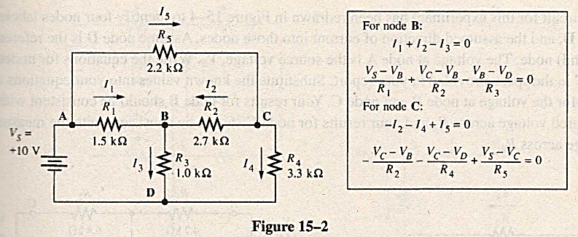

By substituting the known values into the equations given with Figure 15-2, the voltages at nodes C can be found.

PROCEDURE:

1. Measure and record the resistance of the resistors listed in Table 15-1.

2. Construct the bridged-T circuit shown in Figure 15-3. Using the loop equation method illustrated in the Summary of Theory, write a loop equation for loops A, B, and C shown in Figure 15-3. Then, using the method of determinants, solve for each of the loop currents. Show your work in ±e space provided in the report and enter the computed loop currents in Table 15-2.

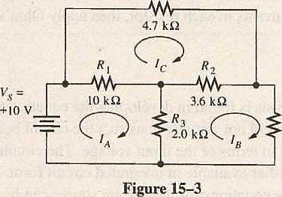

3. Using the computed loop currents, solve for the current in each resistor. Enter the computed Currents in Table 15-2.

4. Using the computed currents in each resistor, apply Ohm’s law to find the computed voltage drop across each resistor. Then, measure the voltage across each resistor in the circuit to confirm your calculated values are correct. Enter the computed and measured voltages in Table 15-3.

5. The circuit for this experiment has been redrawn in Figure 15-4 to identify four nodes labeled A. B, C, D, and the assumed direction of current into those nodes. Assume node D is the reference (ground) node. The voltage at node A is the source voltage, . Write the equations for nodes B and C in the space provided in your report. Substitute the known values into your equations and solve for the voltage at node B and node C. Your results for node B should be consistent with the measured voltage across and 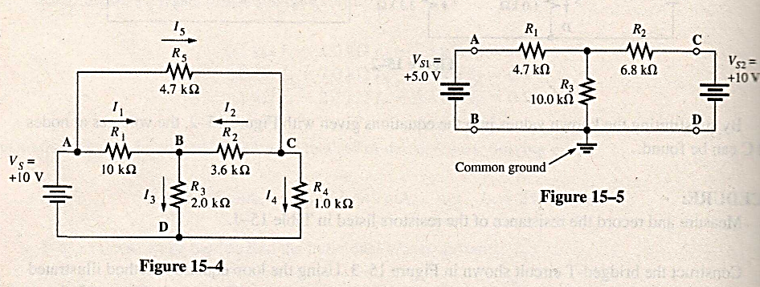your results for node C should be consistent with the measured voltage across

FOR FURTHER INVESTIGATION: (생략)

Loop and node equations are useful for solving problems with more than one source without requiring the superposition theorem. Write loop equations for the two “windows” for the circuit shown in Figure 15-5 (A window is an open section of a circuit with no crossovers. It is bounded on all sides by sources, components, or wiring.) Solve for the currents in each resistor, then apply Ohm’s law and compute the voltage drop across each resistor.

APPLICATION PROBLEM: (생략)

An interesting application of nodal analysis is found in developing the equations for a Howland current source. In this application problem, you will not actually construct the circuit but rather set up the equations to solve for the output current in terms of the input voltage. The circuit uses an operational amplifier (op-amp), a high-gain dc amplifier available in integrated circuit form. By using two approximations for the ideal op-amp, the equations for the current source can be found. The first approximation is that no current flows into the inputs of the op-amp; the second is that the voltage difference across the input terminals is zero.

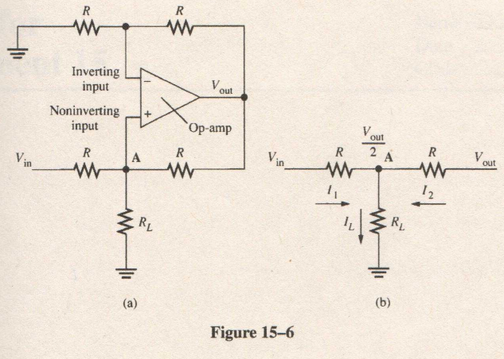

The circuit is shown in Figure 15-6(a). All resistors labeled R are equal. To begin, notice that the upper resistance path consists of a simple unloaded voltage divider (because of the first approximation) Therefore, the voltage on the inverting input terminal is one-half of the output voltage, . The second approximation means that this voltage is also found on the noninverting side of the op-amp. With these approximations, we can redraw the resistors around node A, as shown in Figure 15-6(b). Write a node equation for point A and prove that is equal to .

**Report for**

**Experiment A-5.**

**ABSTRACT**:

**DATA**:

*Loop Equations:*

|  |  |  |  |  |  |  |  |  |  |  |  |  |  |  |  |  |  |  |  |  |  |  |  |  |  |  |  |  |  |  |  |  |  |  |  |  |  |  |  |  |  |  |  |  |  |  |  |  |  |  |  |  |  |  |  |  |
| --- | --- | --- | --- | --- | --- | --- | --- | --- | --- | --- | --- | --- | --- | --- | --- | --- | --- | --- | --- | --- | --- | --- | --- | --- | --- | --- | --- | --- | --- | --- | --- | --- | --- | --- | --- | --- | --- | --- | --- | --- | --- | --- | --- | --- | --- | --- | --- | --- | --- | --- | --- | --- | --- | --- | --- | --- |
| Table 1   |  |  |  | | --- | --- | --- | | Resistor | Listed Value | Measured Value | |  |  |  | |  |  |  | |  |  |  | |  |  |  | |  |  |  | | Table 2   |  |  | | --- | --- | |  | Computed  Current | |  |  | |  |  | |  |  | |  |  | |  |  | |  |  | |  |  | |  |  | | Table 1   |  |  |  | | --- | --- | --- | |  | Computed | Measured | |  |  |  | |  |  |  | |  |  |  | |  |  |  | |  |  |  | |

*Node Equations:*

**RESULTS AND CONCLUSTION**:

**FURTHER INVESTIGATION RESULTS**:

**APPLICATION PROBLEM RESUTLS**:

EVALUATION AND REVIEW QUESTIONS: (생략)

1. As a consistency check on your results, mentally remove R4 from the bridged-T circuit and compute a Thevenin equivalent for the remaining circuit. Then compute the current in R4 if it were connected to your Thevenin equivalent and show that you obtain the same I4.

2. The circuit shown in Figure 15-7(a) shows a bridged-T circuit with all resistances equal to the Thevenin driving resistance of 1.0 kΩ. Assume you need to find the equivalent Thevenin driving impedance of the entire circuit looking from RL. A useful “trick” is to replace the Thevenin source with its equivalent resistance and add a 1V source on the output, as shown in Figure 15—7(b). The current leaving the 1V source can now be calculated by setting up loop equations. Prove that this current is equal to 1 mA (showing that the bridged-T did not change the original driving impedance!).

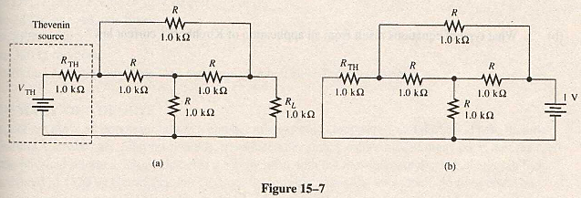

3. Suppose the loop currents in this experiment had been drawn in the opposite direction  
(counterclockwise). What effect does this have on the current in each resistor?

4. The ratio of output voltage to input voltage for a network is called the transfer function of the network. Find the transfer function for the network shown in Figure 15-8 by solving the loop equations (written in the box) for the paths shown. All resistors are equal. Notice that Vout is given by RIb. Then solve for the ratio of Vout/Vin.